1. **Your MAC needs to run OS X 10.7 (Lion) or a more recent version**.  
   [*Find the OS X version of your MAC*](https://support.apple.com/en-us/HT201260)*.*
2. Go to <http://www.oracle.com/technetwork/articles/javase/jdk-netbeans-jsp-142931.html>
3. Click on “Accept License Agreement”
4. Download the file “jdk-8u101-nb-8_1-macosx-x64.dmg” (see below)

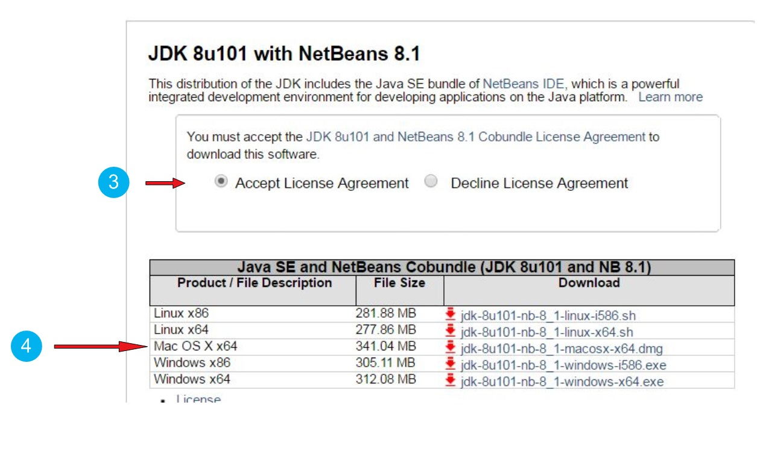

1. Find the file you downloaded on your computer and click on it to install

***Note*** *that you might need administrator rights to install software on your MAC!*

1. During the installation, you might be waiting for a long time (15 minutes or more) at this screen, even if this says that just one minute is remaining. This is normal (see following page!)



Level of difficulty:   
Estimated time: 5 mn + download.

[**www.codapps.io**](http://www.codapps.io)by Clement Levallois **@codapps_io** [**www.coursera.org/learn/codapps**](http://www.coursera.org/learn/codapps)



**Module 1: Installation of useful tools for the course**

*How to install NetBeans and the Codename One plugin on a MAC*

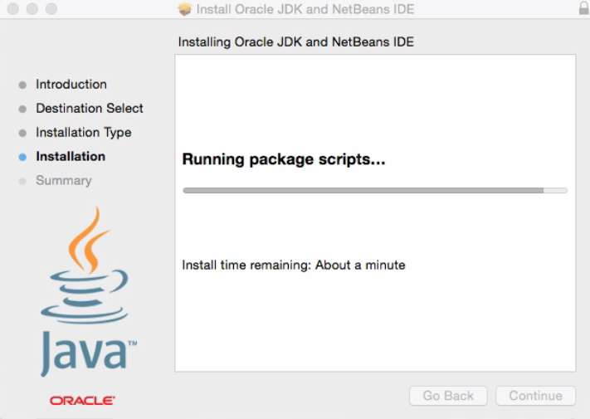

***Now that we have NetBeans installed, let’s add the Codename One plugin.***

1. Open NetBeans. In the menu, select Tools -> Plugins.  
   In the windows opening, select “Available plugins”. Search for “Codename One” (plugins can be listed alphabetically by clicking on the column “name”, that makes it easier to find).  
   Select the Codename One plugin by ticking the box on the left. Click on “Install” and follow instructions.
2. Restart NetBeans to finish the installation.

*Congratulations, you are ready to create your first mobile app!*

Level of difficulty:   
Estimated time: 5 mn + download.

[**www.codapps.io**](http://www.codapps.io)by Clement Levallois **@codapps_io** [**www.coursera.org/learn/codapps**](http://www.coursera.org/learn/codapps)



**Module 1: Installation of useful tools for the course**

*How to install NetBeans and the Codename One plugin on a MAC*